How to write a strong submission to:
Falls to Hotham Alpine Crossing
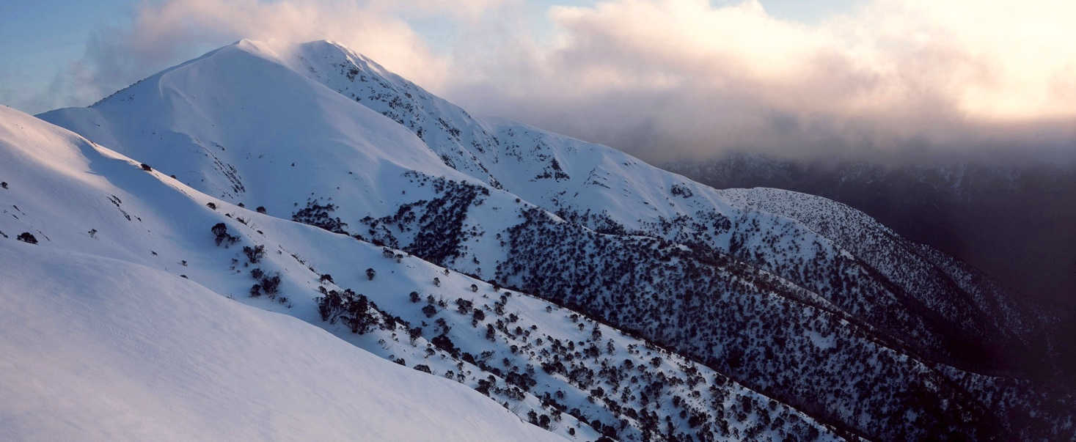

How to structure your submission

1. Introduce yourself

Start your submission by briefly stating who you are, why you care about the Alpine National Park, and why you have taken the time to write your submission.
If you can, establish your credentials by emphasising relevant experiences and qualifications.
Don’t go into too much detail here – you can draw on your personal experiences when talking about any specific issues that matter to you.
Remember: keep your submission polite and respectful. Submissions that are rude or target individual public servants or Members of Parliament will be dismissed.

2. Identify the issues that are important to you

Be strong and clear in your opposition to the proposal. Clearly identify the issues that matter to you. You might find it helpful to turn your chosen issues into headings to guide your submission writing.
Discuss the current situation regarding this issue (for instance the growing trend to develop protected places for commercial gain).
You can elaborate by drawing on your perspective, experience, and evidence to substantiate your claims.
Drawing on your personal experience with environmental issues is one of the most powerful ways to make an impactful submission.
See our key suggestions below for guidance.

3. Use evidence and data to support your statements where possible

A way to show that our laws are failing and bolster your claims on an issue is to use hard evidence – think numbers, peer-reviewed studies, and statistics (if you have them).
This doesn’t have to be formal referencing; you can include links to articles or reports you have read that back your claims. Don’t link to the sources if you feel uncomfortable with the content you are referring to.
It is not necessary to include references but do ensure the points you make in your submission can be supported.

VNPA’s key issues with the Falls to Hotham Crossing

The template is populated with VNPA’s views on the proposal. You can draw on this information for your submission – but please don’t feel limited to the matters raised below.

How to make a submission
- Upload your submission at engage.vic.gov.au
- Be sure to send in your submission before the due date – Sunday 25 September
- If you have questions or would like tips on writing your submission, email VNPA at vnpa@vnpa.org.au
or check out our webpage at vnpa.org.au/stop-alpine-park-development

Template below

On the next page is a basic template that you can edit, adapt to suit your voice and concerns.
Make sure you delete the content on the pages prior (including this one) before you upload your submission!

Name
Address
Email
Phone
Date
Thank you for the opportunity to comment on the proposed ‘Falls to Hotham Crossing’.
I hold several concerns over the proposal as outlined below. After reviewing the material and conducting further research I have concluded that this project raises several ecological issues, policy inconsistencies and – most concerningly – will compromise the very integrity of our national parks estate.
I would like to make it very clear that I strongly oppose the proposed Falls to Hotham Alpine Crossing.
I also object to the nature of the “consultation”. The Engage Victoria questions have been designed to focus on trivial issues, with no opportunity to comment on the value of the project or even to oppose it.
Our Alpine areas are already under stress from climate change and invasive species (such as horses and deer). We should be building resilience into these ecosystems not cutting them up and fragmenting them for luxury huts and development.
I have listed my main concerns in no specific order below:
Protection of alpine habitat, landscapes, and wildlife
The proposed Falls to Hotham crossing will see construction of commercial huts and expanded and widened tracks.
Based on preliminary assessments, this will result in the damage and potential removal of 45 hectares (including 30+ hectares for the four accommodation nodes alone) of native vegetation and habitat within the Alpine National Park.
Within the proposed widened route of the track there are three threatened species of plants. Within the camping and hut nodes, there are fifty-seven threatened plants, animals and insects. There are also stands of increasingly rare and long-unburnt Snow Gums.
Mount Feathertop, at 1922 metres, is one of Victoria’s highest mountains and our grandest free-standing peak. It is a truly magnificent feature of Victoria’s alpine country and deserves rigorous protection. It should be respected, not exploited.
The Bogong High Plains sit at the heart of the Alpine National Park, an area that holds unique and endemic plant life, wildlife and ecosystems found nowhere else on earth.
With the effect of climate change already impacting the alpine regions of Victoria, the added stress to these areas through a massive addition of tourist infrastructure in the heart of the park will have an untold impact on the ecosystems, visual amenity and ambiance of the national park.
National parks law and policy
Parks Victoria has clear obligations under State and Commonwealth legislation to protect the natural heritage of the Alpine National Park. This includes Victoria’s National Parks Act 1975 and the Commonwealth’s Environment Protection and Biodiversity Conservation Act 1999. There are also obligations to provide visitor access to the park, but they are subject to the Act’s biodiversity obligations and heritage listing.

The Alpine National Park is one of Victoria’s grandest areas, and ecologically unique. For these reasons the park was created in the 1980s and, more recently, added to the Commonwealth’s National Heritage listing for the Australian Alps National Parks and Reserves.
That listing speaks strongly of the importance of Australia’s Alpine parks, as: “… one of the most important areas in the southern half of Australia for endemism and species richness”.
In addition, it says the “powerful, aesthetic inspirational qualities of the landscape … have been recognised over a long period of time”. The heritage listing specifically includes Mt Feathertop and the Bogong High Plains in this regard, both of which will be significantly impacted by the development proposal.
Parks Victoria has failed to show how this proposed project has avoided or minimised loss of native vegetation and how the proposal aligns with legislation intended to protect the area.
The Victorian Government has a policy, confirmed as recently as 2021 that: “tourism development will be encouraged to be sited on private or other public land outside national parks”. But $15 million has already be committed by the state government to fund two of the overnight hubs.
This raises a serious question – is this a process of getting around the government’s own policy by funding Parks Victoria to plan and build the infrastructure before handing it to private operators?
The economics don’t stack up
The recently released (but heavily redacted) “Business Case for the FHAC” makes a far from convincing case for the project, listing many cautionary warnings. There is doubt that the returns on the project will cover maintenance costs.
The business case was not assessed against other options for nature-based tourism in the region, such as the promotion and facilitation of short walks from existing high-end accommodation in the Falls Creek and Hotham alpine resorts.
That would be considerably less expensive to implement, likely to attract far more visitors, potentially bring considerable economic benefit to the alpine resorts and the wider region and have far less impact on the national park.
Equity of access to natural areas
According to the Falls to Hotham Alpine Crossing business case, the cost of serviced cabin accommodation would be likely to fall between $440 and $1,065 per night. While there is already ample accommodation for “comfort in nature” park visitors to the area in the two alpine resorts, this project now co-opts the most popular sites for minimal impact, self-sufficient visitors to the Bogong High Plains and Mount Feathertop.
This project is introducing high-end tourism accommodation, operated by commercial operators, to areas which are already very well served by that level of accommodation.
This will see low budget, low impact campers pushed to other areas of the park. Every part of the track is already reachable via day walks from a large range of accommodation in either the Falls Creek or Hotham alpine resorts. There's no need to provide privately catered, built accommodation along the route.
New commercial infrastructure in national parks is unacceptable, especially at a time when other nations and states are removing infrastructure, and increasing their protected areas due to the growing biodiversity crisis. All this at the expense of the remarkable natural ambience and habitat the park currently provides. The project fails any truly objective test of equity of access.
Community engagement
Public criticism of the proposal has been ignored. Of the 229 written public submissions in response to Parks Victoria's earlier draft Master Plan, nearly 90 percent were “strongly opposed”, largely because of the proposed hut and lodge construction. However, Parks Victoria falsely claimed in reporting this feedback that “Overall there was a positive response to the plan and its potential positive impact to the region”.
Parks Victoria has not publicly corrected this statement, despite recognising their error and promising that future communication of public feedback would be reported accurately. The current “Engage Victoria” consultation is largely over trivial issues, with no invitation to comment on the value of the project, let alone oppose it.
There is also little evidence that Traditional Owners have been adequately consulted, and little evidence that ongoing feedback has been sought from our most experienced alpine ecologists, such as the membership of Victoria’s renowned Research Centre for Applied Alpine Ecology. While VNPA is represented on Parks Victoria’s project group, the rest of membership of is tourism-focussed, with only one bushwalking representative.
We continue to highlight concerns throughout the process, including asking for the name of the group to be changed. Crucially, Parks Victoria’s minutes of these meetings do not record feedback from these community representatives.
Safety concerns
Parks Victoria has consistently been warned by experienced walkers that the Diamantina Spur route to Mt Feathertop is too steep and difficult for inexperienced walkers.
The entire walk can be extremely dangerous when the weather closes in, which can happen suddenly at any time of year. Fire in summer and the associated vegetation clearing need for commercial accommodation in bush fire prone areas are potential major risks and impacts.
Well-advised warnings to Parks Victoria, that the inexperienced walkers the proposal is designed to attract would be in danger, have been ignored or dismissed.
The funds outlined to create this project should be reinvested in helping the Alpine National Park – and its threatened plants, animals and ecosystems – adapt to climate change, not to build luxury accommodation for a minority of park visitors.
It is my firm position that this attempt to commercialise the Alpine National Park and compromise its carefully considered management plan must be stopped.
Yours sincerely,

Name
Signature

