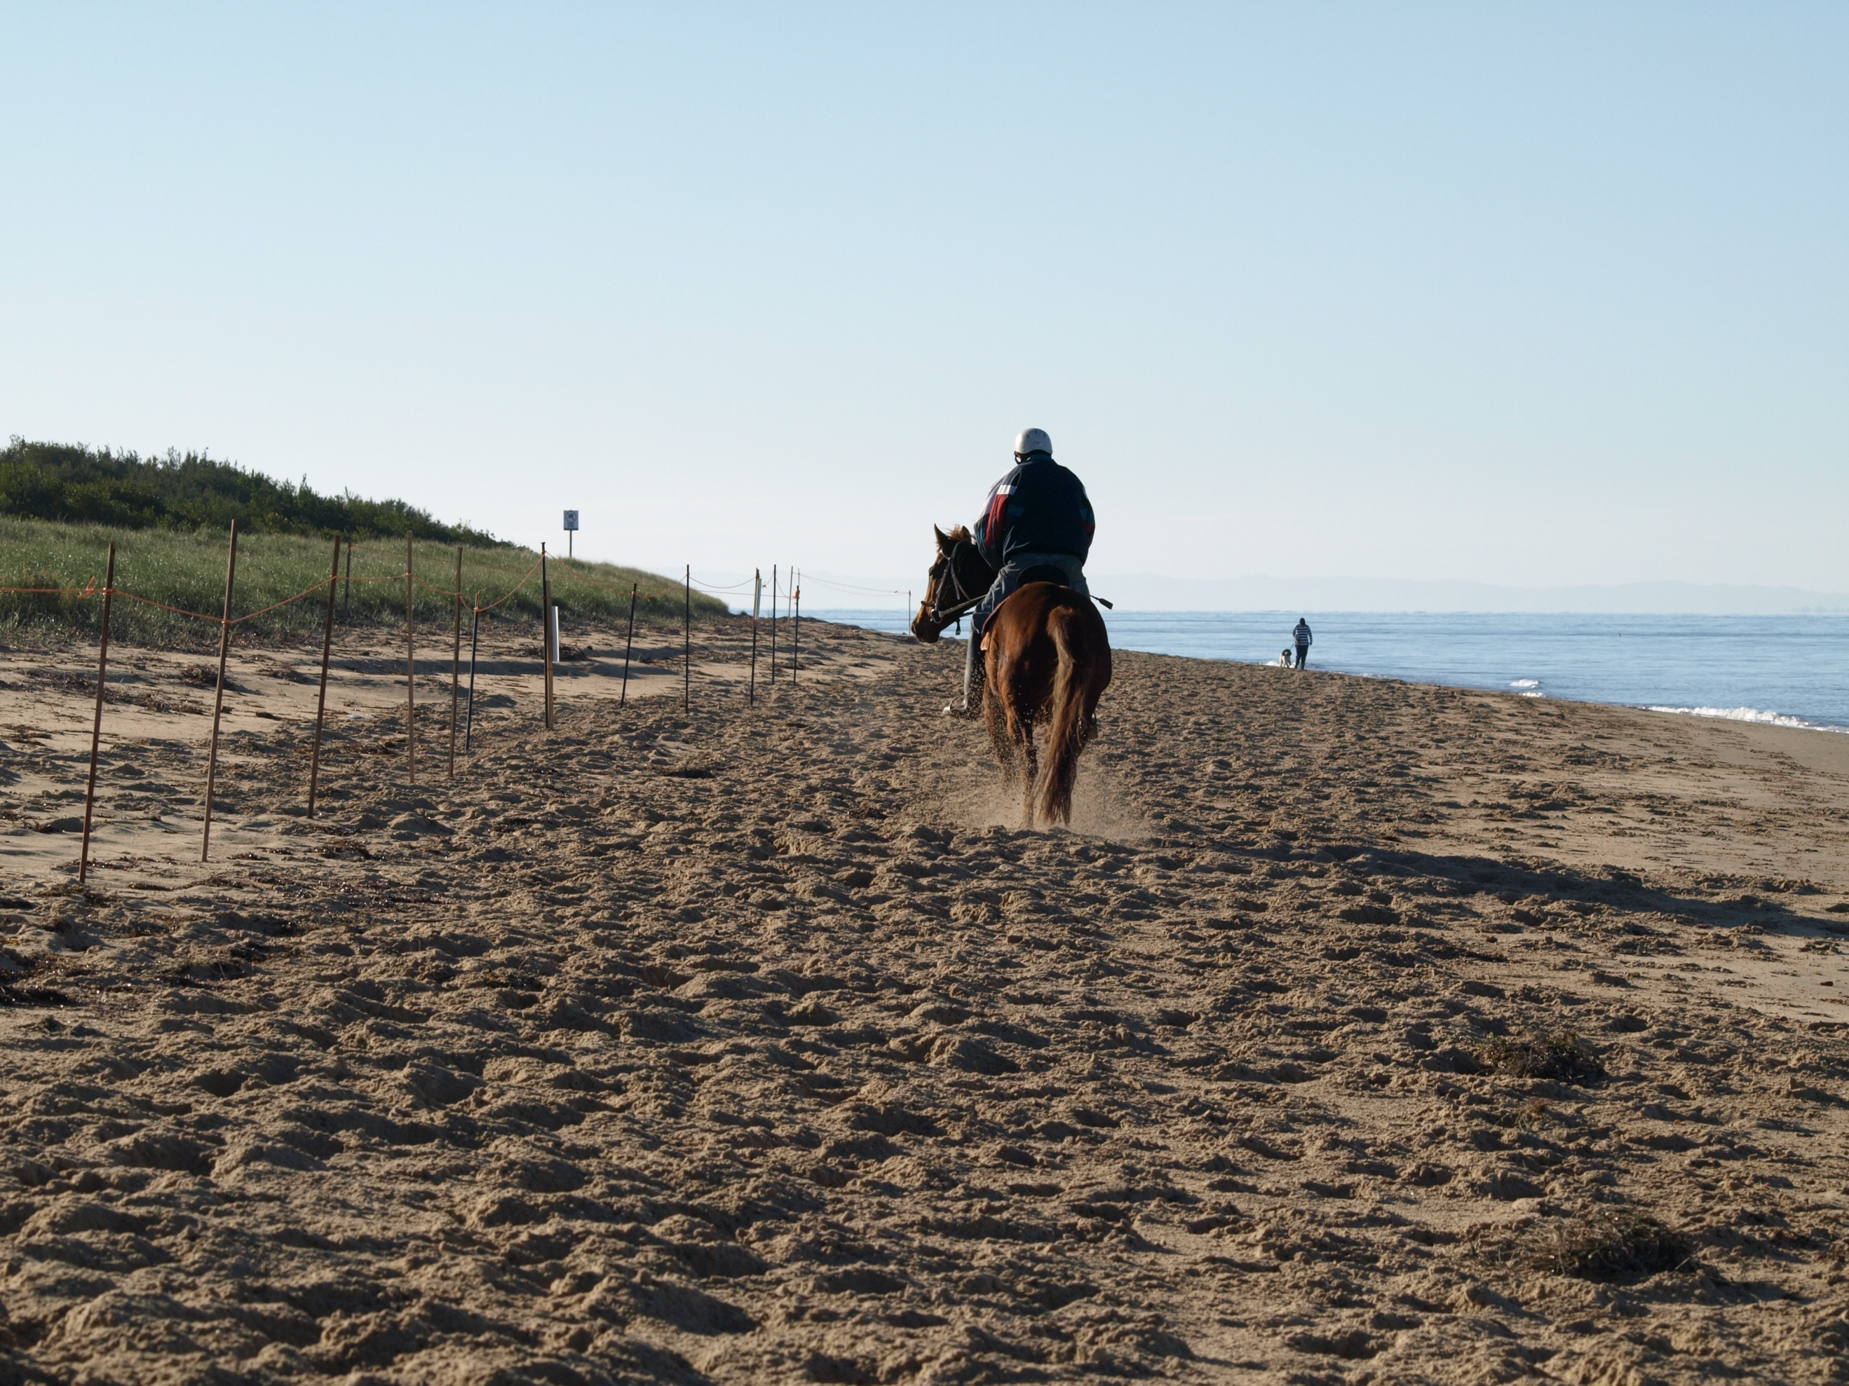
Belfast Coastal Reserve
Draft Management Plan
Submission guide
prepared by the
Victorian National Parks Association
The Victorian National Parks Association has prepared this submission guide and provided dot points (in blue text) for each of the chapters to help with your submission. As for the ticks, we’ll leave that to you should you wish to use them.

Draft Belfast Coastal Reserve Management Plan

About you:

Your name:

Your Organisation (if relevant):

Postcode:

Email or Postal address:

THIS SUBMISSION IS: □ CONFIDENTIAL □ NOT CONFIDENTIAL Date:

Your Comments:

Please Note – The following information will be made publically available.

Main reason for interest: (such as local resident, visitor to parks, tourism operator, environmental interest, business operator, education interest, scientific interest)

General comments that you could make in your submission

- There are many good elements in the draft coastal management plan that I wholeheartedly support: cultural heritage protection; joint management; education and interpretation; monitoring and research; rationalisation and closure of inappropriate beach access; dog control. But it remains deeply flawed because of its complicity in entrenching and expanding the use of the reserve by commercial racehorse trainers.
- Under the plan, commercial racehorse training would rapidly expand to multiple beaches and in sand dunes, with devastating effects for the nationally threatened hooded plovers—the reserve is its most important breeding area in the state according to the plan—other coastal wildlife and the safety and enjoyment of mum, dad and the kids, anglers, surfers and other beachgoers.
- The length of beaches available to racehorse training would, under the plan, be increased by 250% (from 2 km to 5 km) and the number of horses by 400% (from 65 to 256 each day). That represents 25% of the reserve’s beaches, with nothing in the plan to stop future expansion.
- The draft plan would allow racehorses back into 750 metres of fragile dunes behind Levy’s Beach and at Hoon Hill, where in the past they have caused severe dune erosion. The plan even recommends racehorse training within the Conservation Zone at Rutledge’s Cutting. That is inexcusable.
- Many times, the draft plan refers to damage caused by racehorses but fails to explain how increasing the area available to them by 250% will mitigate these impacts. Worse still, the plan’s risk assessment reveals that management won’t make any difference. Before management, the risk to coastal dune vegetation, cultural heritage, resident and migratory shorebirds from racehorse training is rated ‘Extreme’. After management is introduced? The rating remains—Extreme!

- Ever since the uninvited invasion by racehorses in 2015, their training has been mismanaged, with numerous breaches of licensing conditions, public safety put at risk and taxpayers footing the bill for costly Parks Victoria surveillance and infrastructure upgrades. Expanding the number of training beaches will simply make that worse.
- By entrenching and expanding commercial horse training the plan is a relic of past coastal mismanagement and inappropriate use.

Executive summary (pages v-viii)

- The draft plan claims on page vi of the executive summary that it is consistent with the ‘existing strategies and guidelines of relevant governing bodies’. This is simply not true. It is inconsistent with the:
- original and ongoing purpose of the reserve which aims to conserve coastal wildlife and cultural heritage, and support passive recreation and public education
- Victorian Coastal Strategy, which urges that coastal dune and beach systems be protected from damage and that any uses should be coastal dependent, which means they can only be carried out along the coast. Commercial racehorse training is clearly not one of those
- City of Warrnambool’s planning scheme: the Levy’s Beach to Hoon Hill area is covered by a Public Conservation and Resource Zone, which lists the uses that are allowed with or without a permit. Any uses not listed are prohibited. Commercial racehorse training is not listed so should be prohibited.

About the vision- Belfast Coastal Reserve, 15 years from now…: (page 7)

How supportive are you of the vision for the Belfast Coastal Reserve?
□ Very supportive □ Supportive □ Not sure/Don’t know
□ Unsupportive □ Very supportive

Comments: (Your submission can be as short or long as you wish. Put comments under relevant headings corresponding to plan sections or strategies, noting page and paragraph numbers. Attach more pages if required).

Some suggusted comments:

- The vision encapsulates much of what I wish to see in the future for the Belfast Coastal Reserve except for the reference to ‘horse riding’: “The location, timing and intensity of activities such as horse riding has been managed to avoid conflicts between uses, and to reduce the risk of damage to the environment and cultural sites”. The softer term of ‘horse riding’ deflects from the extreme risk and existing damage to wildlife, culture and passive recreation from commercial racehorse training in the reserve. The term ‘horse riding’ should be removed from this statement and commercial racehorse training removed from the Belfast Coastal Reserve. Throughout the rest of the plan there are 24 references to the impacts that horses have on the reserve’s natural, cultural and recreational values. More on this under Key Management Theme #2 Healthy Country.

Key management theme #1: Cultural landscape and living heritage (pages 13-24)

How supportive are you of the strategies for ‘Cultural landscape and living heritage’ included in the draft management plan?

□ Very supportive □ Supportive □ Not sure/Don’t know
□ Unsupportive □ Very Unsupportive

Comments:

Some suggusted comments:

- I strongly support the goals and strategies within this chapter of the draft plan including maintenance of geological features, recognising Traditional Owner and community connections to it, ensuring cultural landscape values are protected in heritage management, and establishing partnerships with Traditional Owners to protect and conserve heritage features. However, one of the strategies—'Work with users and community groups to reduce impacts from both authorised and illegal access on the fragile coastal dune systems’—is expecting too much from community groups to act as delivery partners when those groups will witness daily the extreme damage to sand dunes and beach habitats from commercial racehorse training which, under the plan, will have ‘authorised access’. The goals and strategies also ignore the extreme risk to cultural heritage from commercial racehorse training.

Key management theme #2: Healthy Country (pages 28-42)

How supportive are you of the strategies for ‘Healthy Country’ included in the draft management plan?

□ Very supportive □ Supportive □ Not sure/Don’t know
□ Unsupportive □ Very Unsupportive

Comments:

Some suggusted comments:

- This chapter reveals the draft plan’s underlying contradictions regarding commercial racehorse training. On page 29, the draft plan admits that the extreme risk to coastal habitats, cultural heritage and resident and migratory wildlife from commercial racehorse training will remain so even following management action. This fundamental contradiction in the draft plan will undermine the achievement of the very good goals and strategies in this chapter. The goals to which I give strong support include maintaining and enhancing habitats, reducing the impact of pest species and visitors, better management of marine, lake and swamp habitats, minimising the fire risk and building resilience to climate change.
- It is very pleasing to see one of the strategies under this goal including water management of the Belfast Lough, which until now was not considered as part of the Belfast Coastal Reserve. But the strategy is vague, only referring to maintaining its aquatic values. This needs to be more articulate and refer to water quality, water levels and habitat protection, especially the strong management of motor boats and jet skis, which in the shallow waters can significantly impact on shallow-water habitats and birdlife. Jet skis should be banned from the lough and broader reserve.
- Reducing threats and impacts are a commonly used measure to build resilience to climate change within natural systems. Horses have the most impact in the reserve, especially with regard to dune vegetation and stability. Sea-level rise may reduce the width of beaches and intensify the impacts of racehorses on that habitat. The best way to build resilience is to get the racehorses out.

Key management theme #3: Recreation and use (pages 45-69)

How supportive are you of the strategies for ‘Recreation and use’ included in the draft management plan?

□ Very supportive □ Supportive □ Not sure/Don’t know
□ Unsupportive □ Very Unsupportive

Comments:

Some suggusted comments:

- I strongly support many of the goals and strategies that relate to the recreational use of the Belfast Coastal Reserve in this chapter including increased enforcement, better management of vehicular use, dog walking and recreational horse riding, bans on dune boarding, hunting and off-road vehicles, reducing risks and improving safety, improving information, interpretation and education, and developing tourism partnerships, marketing and promotion. But without the removal of commercial racehorse training, these goals will not be achieved.
- A far more honest heading for this chapter would be ‘Recreational and commercial use’. Too often the plan seeks to confuse recreational riding and commercial racehorse training or to downplay the intensity and impacts of the commercial activity, continually referring to the training as a ‘licensed’ or ‘authorised’ use to convey that it is not negotiable, it cannot be restricted or removed. By including it within a chapter mainly on ‘recreation’, it again tries to downplay the highly commercial and intensive nature of racehorse training.
- The draft plan recommends strict controls on where and how recreational uses are to be managed in the future, whereas commercial racehorse training will be expanded. That doesn’t make sense.
- In the introduction to this chapter, the draft plan states, with my underlining: Riding of horses for recreational or commercial purposes was viewed as a threat to dune health, cultural heritage, shorebirds and public safety, especially if riders did not comply with regulations, codes of conduct or licence conditions. This suggests that the community is mainly concerned about impacts that occur when commercial racehorse training doesn’t follow the rules. But as the risk assessment table reveals on page 29, even with rules, management will not mitigate the extreme risk from commercial racehorse training.
- Jet skis should not be allowed in reserve waters, including Belfast Lough, because of their disturbance to wildlife and other recreational users, and damage to shallow water habitats.
- Dogs should not be allowed off-leash from 1 August to 30 November at Killarney Beach, coinciding with the first part of the hooded plover breeding season.
- It is ludicrous to consider renaming Hoon Hill to ‘improve expectations on visitor behaviour’ when those same visitors will witness racehorses and their riders ‘hooning’ up and down the dunes of the hill.
- Section 6.5 of this chapter is titled ‘Authorised uses’, code for commercial racehorse training. Much of the emphasis in this section is the regional economic importance of the racing industry as justification for the damage that it is causing and will continue to cause if it remains in the Belfast Coastal Reserve. But in a September 2013 report prepared for the Victorian racing industry by consultants IER, it was revealed that the racing industry generates $75 million gross value added in the Western District, which includes Warrnambool but also a number of other racing clubs at Casterton, Coleraine, Hamilton, Terang, Camperdown Mortlake, Penshurst and Dunkeld. The report also reveals that 40% of statewide gross value added for horse racing is from gambling, which takes money out of the community. If applied to the Western District, $30million of the gross value added would be from gambling, which leaves $45million shared across all of the region’s clubs.
- This is tiny relative to other sectors in the regional economy. Most jobs are provided by the healthcare and social assistance, retail and accommodation and food services sectors. Tourism generates more than half of Warrnambool’s total economic output of $3.3billion. Except for the May Racing Carnival being mentioned in a dot point in an event strategy, the racing industry in Warrnambool is ignored in the Warrnambool Economic Development and Investment Strategy 2015-2020 prepared by the Coty of Warrnambool.
- It appears that the main reason for justifying a huge expansion in commercial racehorse training is ‘due to community interest’ and so the ‘plan sets out an approach for horse training that balances support for the racing industry, equity of access for all trainers and ensuring adequate protection for cultural and natural values’. The consultation carried out by Parks Victoria confirmed the serious concerns the community had about commercial racehorse training, but that is now being referred to as ‘community interest’ that justifies the racing industry’s use of the reserve. It sounds ludicrous and it is.
- I strongly condemn the goal under this section of the chapter—Authorised uses of the Reserve are managed to minimise the effect on values and visitors—with regards to commercial racehorse training as it is incompatible with the goals of the plan and the purposes of the reserve.

Key management theme #4: Managing in partnership (pages 71-75)

How supportive are you of the strategies for ‘Managing in partnership’ included in the draft management plan?

□ Very supportive □ Supportive □ Not sure/Don’t know
□ Unsupportive □ Very Unsupportive

Comments:

Some suggusted comments:

- I strongly support the first goal in this chapter: Coordinated management of the Reserve enables efficiencies in program delivery and is supported by consistent land status and regulations. But I cannot support the strategies that aim to achieve it. The plan recommends retaining the fragmented management across the City of Warrnambool, Moyne Shire Council and Parks Victoria and leaving the reserve under the Crown Lands (Reserves) Act. The reserve should become a park under the National Parks Act.
- I also strongly support goals to ensure that Traditional Owners caring for their Country is an integral part of the reserve’s management and that community skills, knowledge and assistance provide stewardship and help in that management. However, if commercial racehorse training is retained inside the reserve, all of their efforts would be to nought.

Key management theme #5: Research and monitoring (page 77-79)

How supportive are you of the strategies for ‘Research and monitoring’ included in the draft management plan?

□ Very supportive □ Supportive □ Not sure/Don’t know
□ Unsupportive □ Very Unsupportive

Comments:

Some suggusted comments:

- I strongly support this chapter’s goal and strategies and the indicators to be used to evaluate the effectiveness of the management plan. However, the plan fails to explain how it will lower the extreme risk presented by commercial racehorse training revealed in the table on page 29. That table proves that it cannot and so commercial racehorse training should be removed from the reserve.

